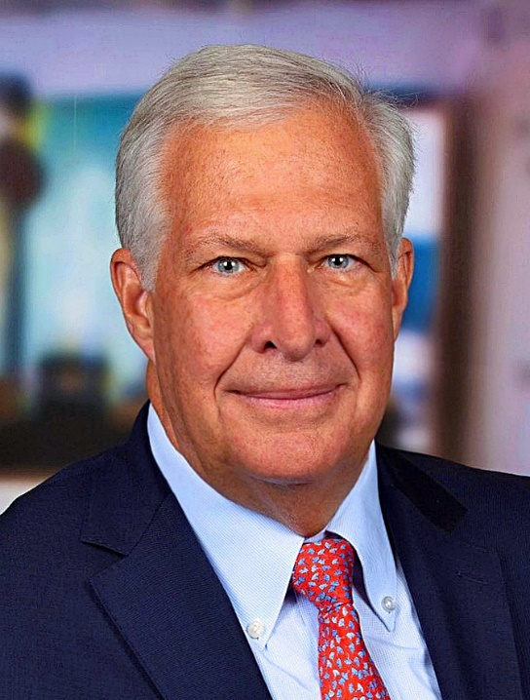
Walter Kress
With four decades of comprehensive experience in both sell-side and buy-side investment management, Walter serves as the Chief Investment Officer at EY U.S., leading the team of five responsible for overseeing EY’s $30+ billion of qualified and non-qualified retirement plans. Walter is also a member of the Investment Committee for EY Global captive insurance company.
Before joining EY, Walter spent a decade at JPMorgan, where he was a key member of the Retirement Plan Investment Group. His roles included Chief Operating Officer and portfolio manager for private equity, real estate, and real assets, as well as serving as a designated advisor to the investment committees of the firm’s largest international retirement plans.
Walter's earlier career included leadership roles at Mellon and its Dreyfus subsidiary, where he was National Sales Manager of Retail at Dreyfus and Executive Vice President of Defined Contribution Distribution at Mellon Institutional Asset Management. His investment career began at Prudential Securities, where he spent 14 years in roles including Branch Manager and Associate Regional Director. He has focused on the ERISA retirement plan market since 1990.
Chief Investment Officer honored Walter with their Lifetime Achievement Award in 2022, their Most Collaborative Award in 2021 and included him in their Power 100 list from 2021 to 2025. Institutional Investor awarded him their Excellence in Retirement Structure Award in 2016 and their Visionary Award in 2025. Markets Group included Walter in their 2026 Elite Institutional CIOs list.
Walter is on the Board and Chair of the Defined Contribution Committee for CIEBA (the Committee for the Investment of Employee Benefit Assets). He sits on the Board for Catch-a-Lift, a national Veteran’s support organization, and is Chair of the New York Yacht Club’s Investment Committee. Elected to the Board of Finance in Wilton, CT, in 2015, he served as Vice Chair from 2018 to 2019. Walter earned a B.S. in Finance from Syracuse University.

